



**SAVEETHA SCHOOL OF ENGINEERING**

**SAVEETHA INSTITUTE OF MEDICAL AND TECHNICAL SCIENCES**

**CHENNAI-602105**

**E-COMMERCE WEBSITE**

**A CAPSTONE PROJECT REPORT**

*Submitted in the partial fulfillment for the completion of the course*

**CSA4317 INTERNET PROGRAMMING WITH MOBILE APP INTEGRATION**

**IN**

**COMPUTER SCIENCE AND ENGINEERING**

**Submitted by**

**S. SHAHEED BASHA  192210281**

**N. HARSHA VARDHAN  192211571**

**Under the Supervision of**

**Ms. L. REETHA**

**NOV** **2024**

**DECLARATION**

We Shaheed, Harsha, students of **Bachelor of Engineering in the Department** of Computer Science and Engineering, Saveetha Institute of Medical and Technical Sciences, Saveetha School of Engineering, Chennai, hereby declare that the work presented in this Capstone Project Work entitled **E-commerce website** is the outcome of our Bonafide work and is correct to the best of our knowledge and this work has been undertaken taking care of Engineering Ethics.

(Shaheed Basha 192210281)

(Harsha Vardhan 192211571)

Date:

Place:

**CERTIFICATE**

This is to certify that the project entitled “**E-commerce website**” submitted by **Shaheed, Harsha** has been carried out under my supervision. The project has been submitted as per the requirements in the current semester of B.E. Computer Science and Engineering.

Supervisor

Ms. L. Reetha

**Table of Contents**

| **S.NO** | **TOPICS** | **PAGE NO.** |
| --- | --- | --- |
| 1 | **Abstract** | 5-5 |
| 2 | **Introduction** | 5-6 |
| 3 | **Project Description** | 6-7 |
| 4 | **Problem Description** | 8-8 |
| 5 | **Tool Description** | 8-11 |
| 6 | **Module Description** | 11-11 |
| 7 | **Operations** | 12-15 |
| 9 | **Result** | 16-18 |
| 10 | **Conclusion** **& References** | 19-20 |

**ABSTRACT**

E-Commerce, the digital exchange of goods and services over the internet, has fundamentally transformed the global marketplace. This paper explores the evolution of e-commerce, examining its impact on businesses, consumers, and economies. It traces the development of e-commerce platforms, the adoption of various business models (B2B, B2C, C2C), and the technological innovations that have driven growth, such as mobile commerce, artificial intelligence, and blockchain. The study highlights key factors influencing the success of e-commerce, including user experience, digital marketing strategies, logistics, and cybersecurity. It also addresses the challenges and risks posed by the digital environment, such as fraud, data privacy concerns, and market saturation. Ultimately, this paper underscores the ongoing potential of e-commerce to redefine traditional business practices, enhance consumer engagement, and foster global economic integration.

As e-commerce continues to evolve, it is increasingly shaping consumer behavior and business strategies. The rise of social media platforms, personalized marketing, and targeted advertising has made it easier for companies to reach and engage their audiences, while simultaneously offering consumers more tailored shopping experiences. Mobile commerce, in particular, has gained significant traction, with smartphones becoming central hubs for online shopping, payment processing, and customer service interactions. Additionally, innovations such as virtual and augmented reality are beginning to reshape product discovery and virtual storefronts, further enhancing the digital shopping experience. However, with the rapid growth of e-commerce, there is also a growing need for businesses to prioritize sustainability, ethical practices, and transparent customer relationships. This paper explores the emerging trends and technologies that are set to influence the future of e-commerce, as well as the broader implications for market competition, consumer trust, and regulatory frameworks.

**INTRODUCTION**

The rise of e-commerce has revolutionized the way businesses operate and how consumers interact with the marketplace. Over the past few decades, the internet has transitioned from a tool for communication and information sharing to a powerful engine for global commerce. E-commerce, which involves the buying and selling of goods and services through digital platforms, has become an integral part of the global economy, enabling businesses to reach customers across geographic boundaries and time zones. The convenience of online shopping, coupled with advancements in payment systems, logistics, and digital marketing, has made e-commerce a dominant force in retail, finance, and many other industries.

The expansion of e-commerce has been accelerated by the growing prevalence of smartphones, the rise of social media platforms, and innovations in artificial intelligence, all of which have made online shopping more personalized, accessible, and engaging for consumers. At the same time, e-commerce has opened up new business models, including business-to-consumer (B2C), business-to-business (B2B), and consumer-to-consumer (C2C), creating a dynamic and highly competitive environment. As the digital marketplace continues to expand, it is reshaping traditional business practices, challenging established retailers, and presenting both opportunities and challenges for companies and consumers alike.This paper explores the evolution, impact, and future of e-commerce, examining its key drivers, the technologies shaping its growth, and the challenges it presents to businesses, consumers, and regulators.

**PROJECT DESCRIPTION**

This project aims to develop a comprehensive e-commerce platform designed to provide a seamless online shopping experience for both consumers and businesses. The platform will facilitate the buying and selling of products across multiple categories, including electronics, apparel, home goods, and more, while integrating advanced features to enhance usability, security, and scalability. The project will focus on creating a user-friendly interface that allows customers to easily browse, search, and purchase products, while also enabling businesses to manage inventory, process orders, and track customer data efficiently.

**Key components of the project include:**

**1.Product Catalog and Search Functionality**: A robust product catalog with intuitive categorization and a powerful search engine that allows users to filter products based on various attributes such as price, brand, ratings, and more. Advanced features like predictive search and personalized recommendations will enhance the shopping experience.

**2.Secure Payment Gateway**: Integration of a secure and reliable payment system that supports various payment methods, including credit cards, digital wallets, and bank transfers, ensuring customer transactions are processed smoothly and securely.

**3.User Authentication and Account Management**: Features for user registration, account management, and secure login, allowing customers to track their orders, save preferences, and receive personalized offers and notifications.

**4.Mobile Compatibility**: A responsive design optimized for mobile devices, ensuring that customers can shop conveniently from smartphones and tablets.

**5.Order Management and Logistics Integration**: A backend system that allows businesses to manage orders, track inventory in real-time, and integrate with third-party logistics providers for efficient shipping and delivery.

**6.Customer Support and Feedback Mechanism**: A live chat feature, automated customer support, and easy access to return policies, FAQs, and product reviews, creating a transparent and user-centric environment.

**7Analytics and Reporting Tools**: Advanced analytics to track sales, customer behavior, and product performance, helping businesses make data-driven decisions for inventory management, marketing strategies, and customer engagement.

The project also focuses on incorporating security measures to protect user data, including encryption protocols, secure browsing, and compliance with data protection regulations such as GDPR. By combining cutting-edge technologies with a customer-centric approach, this e-commerce platform will provide businesses with the tools they need to thrive in a competitive digital landscape, while offering consumers an enjoyable, secure, and efficient shopping experience. Ultimately, this project seeks to deliver a scalable, flexible, and innovative e-commerce solution that meets the evolving demands of both businesses and consumers in the rapidly growing digital marketplace.

**PROBLEM DESCRIPTION**

 This project aims to develop a comprehensive e-commerce platform designed to provide a seamless online shopping experience for both consumers and businesses. The platform will facilitate the buying and selling of products across multiple categories, including electronics, apparel, home goods, and more, while integrating advanced features to enhance usability, security, and scalability. The project will focus on creating a user-friendly interface that allows customers to easily browse, search, and purchase products, while also enabling businesses to manage inventory, process orders, and track customer data efficiently.

**Key components of the project include:**

1. **Product Catalog and Search Functionality**: A robust product catalog with intuitive categorization and a powerful search engine that allows users to filter products based on various attributes such as price, brand, ratings, and more. Advanced features like predictive search and personalized recommendations will enhance the shopping experience.
2. **Secure Payment Gateway**: Integration of a secure and reliable payment system that supports various payment methods, including credit cards, digital wallets, and bank transfers, ensuring customer transactions are processed smoothly and securely.
3. **User Authentication and Account Management**: Features for user registration, account management, and secure login, allowing customers to track their orders, save preferences, and receive personalized offers and notifications.
4. **Mobile Compatibility**: A responsive design optimized for mobile devices, ensuring that customers can shop conveniently from smartphones and tablets.
5. **Order Management and Logistics Integration**: A backend system that allows businesses to manage orders, track inventory in real-time, and integrate with third-party logistics providers for efficient shipping and delivery.
6. **Customer Support and Feedback Mechanism**: A live chat feature, automated customer support, and easy access to return policies, FAQs, and product reviews, creating a transparent and user-centric environment.
7. **Analytics and Reporting Tools**: Advanced analytics to track sales, customer behavior, and product performance, helping businesses make data-driven decisions for inventory management, marketing strategies, and customer engagement.

1. **User Experience and Navigation Issues**: Many e-commerce platforms suffer from poor user interfaces and confusing navigation. Consumers often face difficulties in finding the products they want, especially when the search functionality is inadequate or product categorization is unclear. This leads to a frustrating shopping experience, higher bounce rates, and ultimately lost sales. Additionally, many e-commerce sites lack personalization, meaning customers are not always presented with relevant products or recommendations, which can result in missed opportunities for both upselling and customer satisfaction.
2. **Security and Data Privacy Concerns**: As the volume of online transactions continues to grow, so do the risks associated with data security. Many e-commerce sites struggle to implement robust security measures to protect sensitive customer information, including personal data, payment details, and transaction histories. Cybersecurity threats, such as data breaches, identity theft, and payment fraud, have become significant concerns for consumers and businesses alike. Failure to safeguard this data can lead to customer distrust, reputational damage, and legal consequences.
3. **Logistics and Order Fulfillment Challenges**: Efficient logistics and timely order fulfillment remain critical issues for many e-commerce businesses. From inventory management to shipping delays, businesses often encounter difficulties in ensuring that orders are processed, packed, and delivered on time. Inconsistent delivery times, stockouts, and inventory discrepancies can result in customer dissatisfaction, negative reviews, and lost sales. Additionally, high shipping costs and a lack of integration with reliable delivery providers can impact overall profitability.
4. **Payment and Transaction Failures**: E-commerce platforms frequently face challenges related to payment gateway issues, such as transaction errors, delays in payment processing, and a lack of support for diverse payment methods. This can result in abandoned carts, customer frustration, and a decline in sales conversion rates. Additionally, cross-border transactions may be complicated by currency conversion issues, payment fraud risks, or regulatory barriers, particularly for businesses aiming to operate globally.
5. **Customer Trust and Retention**: In an increasingly crowded digital marketplace, businesses struggle to build trust and retain customers. With the abundance of options available, consumers are often hesitant to make purchases from unfamiliar online stores. Lack of customer service support, insufficient product information, and unclear return policies can further exacerbate trust issues. Building strong relationships with customers is essential for e-commerce businesses to encourage repeat purchases and foster brand loyalty.

1. **Market Competition and Saturation**: The e-commerce market is highly competitive, with new entrants constantly emerging and established players continuing to innovate. As a result, smaller businesses may struggle to compete with larger, well-funded companies that have more resources for marketing, technology, and logistics. The challenge lies in differentiating a brand, building customer loyalty, and offering unique value propositions that stand out in a crowded online marketplace.

**2.Regulatory and Compliance Issues**: With the rapid growth of e-commerce comes the need to comply with a variety of regional and international laws, including data protection regulations (such as GDPR), tax collection laws, and product safety standards. E-commerce businesses often struggle to stay updated on evolving legal frameworks, which can lead to non-compliance, penalties, or legal disputes.

These challenges represent critical issues that businesses and consumers face in the e-commerce space. Addressing them requires innovative solutions in areas such as user interface design, security infrastructure, logistics optimization, payment systems, customer engagement, and legal compliance. Developing a comprehensive e-commerce platform that effectively mitigates these challenges can enhance user experience, improve operational efficiency, and foster long-term customer relationships, ultimately leading to sustained success in the digital marketplace

**BLOCK DIAGRAM**

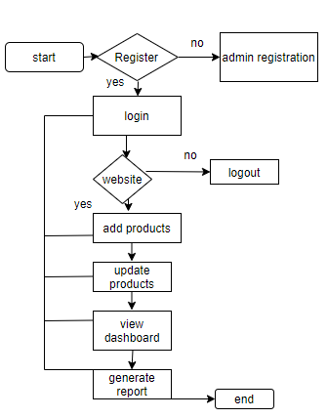

**Operations:**

1. The operations of an e-commerce business encompass a wide range of activities that work together tensure the smooth and efficient functioning of the online store, from product sourcing and marketing to order fulfillment and customer service. Below are the key operational areas involved in running an e-commerce business:

**1. Product Sourcing and Inventory Management**

* **Product Sourcing**: This refers to the process of identifying and obtaining the products that will be sold on the platform. E-commerce businesses may source products directly from manufacturers, wholesalers, or through drop shipping arrangements where the product is shipped directly from a third party.
* **Inventory Management**: Managing inventory is crucial to ensure that the right products are available in stock and ready to ship. Inventory management involves tracking stock levels, forecasting demand, and replenishing stock to avoid overstocking or stockouts. Advanced inventory management systems can integrate with e-commerce platforms to provide real-time data on product availability and sales trends.

**2. Website Development and Maintenance**

**i. Platform Design and Functionality**: A well-designed website or mobile app is essential for user engagement. This includes having an intuitive navigation structure, an easy-to-use search and filtering system, and a seamless checkout process. The website should be responsive and mobile-optimized, as a significant portion of e-commerce sales now come from mobile devices.

**ii. Content Management**: Regular updates to the website, including product descriptions, images, videos, promotions, and seasonal content, are important to keep the platform fresh and engaging. This requires the integration of a content management system (CMS) that allows easy editing and updating.

**3. Order Management and Fulfilment**

* **Order Processing**: Once a customer places an order, the business must confirm the transaction, process the payment, and notify the customer. Order management systems (OMS) help automate this process, ensuring that all steps are followed in a timely and accurate manner.
* **Packaging and Shipping**: After processing an order, products must be packed and prepared for shipment. This involves choosing the right packaging materials, organizing shipping routes, and selecting a reliable shipping partner. Many e-commerce businesses integrate with third-party logistics (3PL) providers to manage warehousing and fulfillment.
* **Returns and Exchanges**: E-commerce businesses need a clear and efficient process for handling returns and exchanges. Customers expect an easy process for returning products, which may involve issuing refunds, offering replacements, or providing store credits.

**4. Payment Processing**

* **Payment Gateway Integration**: E-commerce platforms need to support multiple payment methods such as credit/debit cards, digital wallets (PayPal, Apple Pay, etc.), and bank transfers. A payment gateway securely processes transactions and ensures that funds are transferred from the customer to the business.
* **Fraud Prevention and Security**: Protecting customer financial information is critical. E-commerce businesses must implement encryption protocols (such as SSL certificates) to secure transactions, as well as fraud detection systems to minimize chargebacks and fraudulent activities.

**5. Customer Relationship Management (CRM)**

* **Customer Support**: A strong customer service function is essential for addressing issues such as order inquiries, product questions, and complaints. This can include live chat support, phone support, email, or automated AI-based chatbots that offer immediate assistance.
* **Personalization and Engagement**: Personalizing the shopping experience can improve customer retention. This includes recommending products based on past browsing or purchase behavior, offering targeted discounts, or sending personalized emails and promotions.
* **Loyalty Programs**: Many e-commerce businesses implement loyalty programs to reward repeat customers, encourage referrals, and incentivize higher-value purchases.

**6. Marketing and Advertising**

* **Digital Marketing Campaigns**: E-commerce businesses rely heavily on online marketing to drive traffic to their websites. Key strategies include search engine optimization (SEO), pay-per-click (PPC) advertising, email marketing, social media advertising, and influencer partnerships.
* **Social Media Management**: Social media platforms such as Instagram, Facebook, TikTok, and Pinterest have become essential tools for promoting products, engaging with customers, and building brand awareness. Regular content creation, paid ads, and customer engagement through social media are key aspects of e-commerce operations.
* **Affiliate Marketing and Influencer Partnerships**: E-commerce businesses often leverage affiliate programs and work with influencers to drive traffic to their sites and generate sales. This involves paying partners a commission for each sale made through their promotional efforts.

**7. Data Analytics and Reporting**

* **Performance Metrics**: Monitoring key performance indicators (KPIs) such as conversion rates, average order value, cart abandonment rates, and customer acquisition cost (CAC) helps e-commerce businesses identify strengths and areas for improvement.
* **Sales and Inventory Forecasting**: Analyzing sales data and customer behavior trends allows businesses to forecast demand, optimize inventory levels, and create effective marketing campaigns.
* **Customer Insights**: By analyzing customer data (e.g., purchase history, demographics), businesses can create more effective marketing strategies, improve product offerings, and increase customer satisfaction.

**8. Legal and Compliance Management**

* **Tax Collection and Regulations**: E-commerce businesses must comply with tax laws in various regions, including sales tax or VAT requirements, and ensure that they are collecting taxes appropriately at checkout.
* **Data Privacy Compliance**: Adherence to privacy laws, such as GDPR in Europe or CCPA in California, is essential. E-commerce businesses must ensure that they handle customer data securely, with clear consent for collection and use.
* **Product Compliance**: Businesses must ensure that the products they sell meet safety standards, regulatory requirements, and any applicable industry certifications (e.g., CE marking for electronics, health and safety standards for food products).

**9. Supply Chain and Vendor Management**

**i.Supplier Relationships**: E-commerce businesses rely on strong relationships with suppliers, manufacturers, and distributors. Effective communication and collaboration are key to ensuring timely product deliveries and consistent product quality.

**ii.Outsourcing and Dropshipping**: Many businesses use dropshipping models, where products are shipped directly from third-party suppliers to customers. Managing these relationships, ensuring supplier reliability, and negotiating favorable terms are critical to the success of the business.

**10. Technology Infrastructure and Support**

**i.Platform Integration**: Many e-commerce platforms use third-party tools for various aspects of their operations (payment gateways, marketing platforms, customer service, etc.). Ensuring these tools are properly integrated and work seamlessly is crucial for smooth operations.

**ii.Scalability**: As an e-commerce business grows, its technological infrastructure must be able to handle increased traffic, larger inventories, and a larger volume of transactions. Cloud-based platforms and scalable solutions are key to ensuring that the business can adapt to growth without service interruptions.

**RESULT:**

**Figure 1: Home** **page**



**Figure 2: Login Page**



**Figure 3: Order Page**

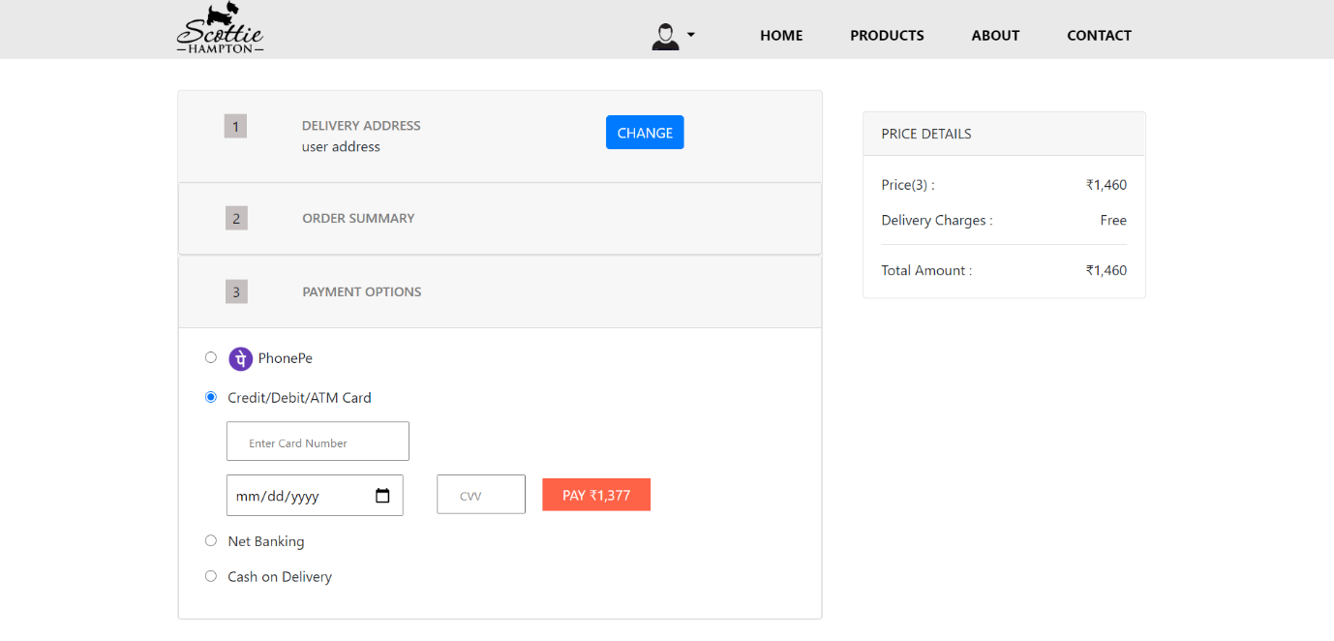

DATABASE

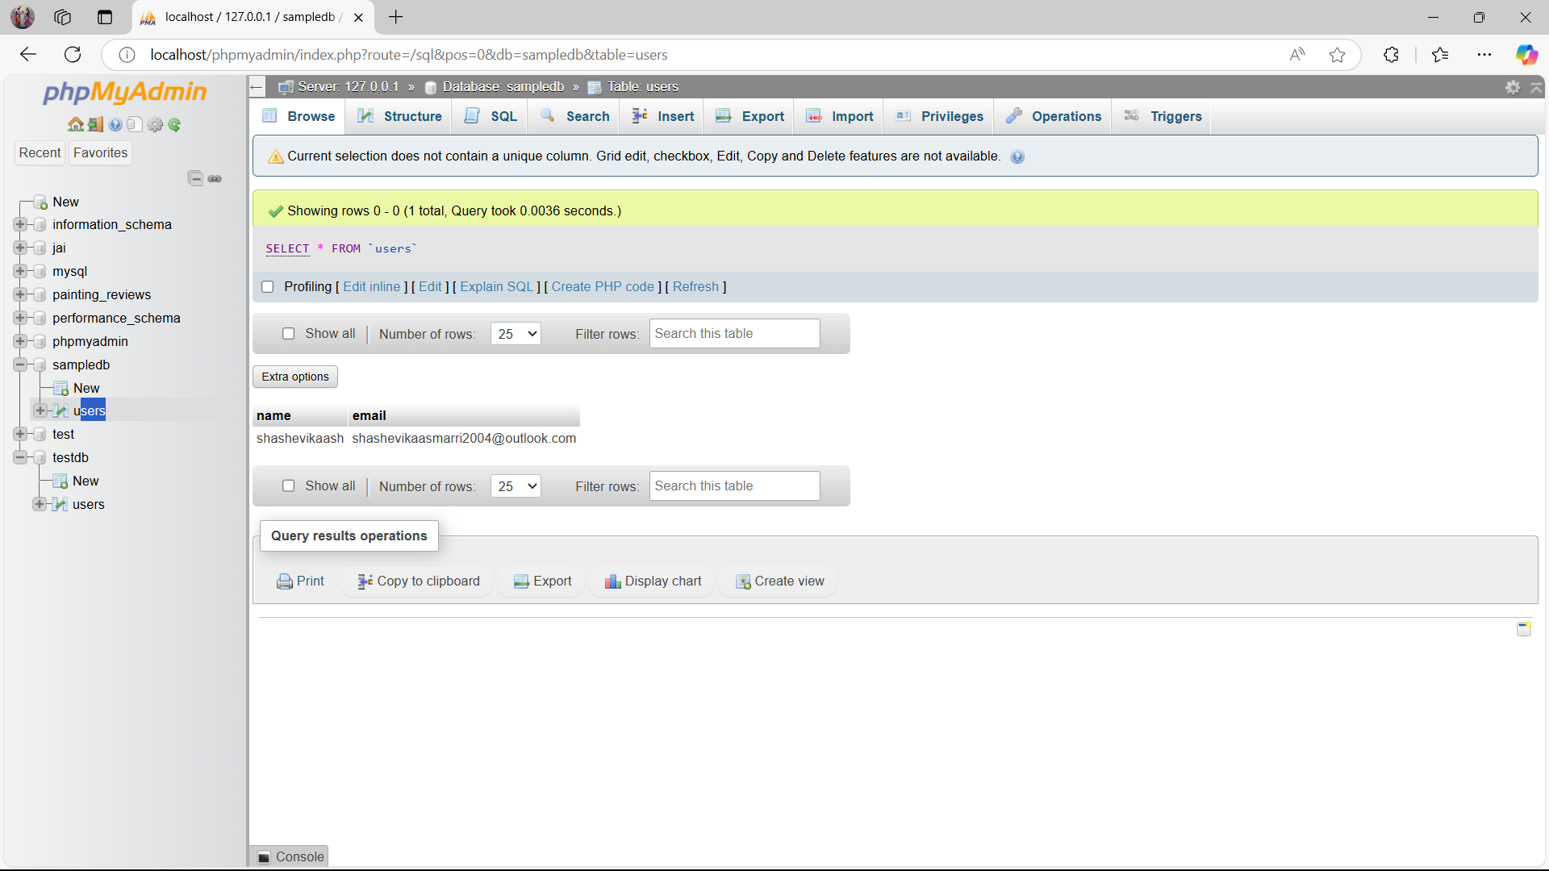

**Conclusion:**

Successful e-commerce operations require careful coordination across all of these areas to ensure the business runs smoothly, delivers a superior customer experience, and remains competitive in the marketplace. A well-integrated system of inventory management, payment processing, order fulfillment, customer service, marketing, and compliance is essential to drive growth and profitability in the dynamic world of online retail. By optimizing these operational processes and leveraging technology, e-commerce businesses can scale effectively and meet the evolving demands of consumers.

**Reference:**

1. **Laudon, K. C., & Traver, C. G.** (2021). *E-commerce: Business, Technology, Society* (15th ed.). Pearson.
2. This textbook offers a comprehensive overview of the e-commerce ecosystem, including business models, technology infrastructure, and social and economic impacts. It covers current trends, case studies, and the evolution of e-commerce over time.
3. **Chaffey, D.** (2019). *Digital Marketing: Strategy, Implementation, and Practice* (7th ed.). Pearson Education.
4. This book covers digital marketing techniques, which are crucial for e-commerce businesses to attract and retain customers. It includes strategies for search engine optimization (SEO), pay-per-click advertising (PPC), email marketing, and social media.
5. **Kalakota, R., & Whinston, A. B.** (1997). *Electronic Commerce: A Manager's Guide*. Addison-Wesley.
6. A foundational text in the e-commerce field, this book offers practical insights into how businesses can implement e-commerce technologies, manage e-commerce operations, and address business challenges in an online environment.

**7.Brynjolfsson, E., & Smith, M. D.** (2000). *Frictionless Commerce? A Comparison of Internet and Conventional Retailers*. *Management Science, 46*(4), 563-585.

8. This academic article explores how the internet has reduced transactional costs in commerce, comparing traditional and online retail environments. It provides valuable insights into e-commerce's competitive advantages.

**9.Laudon, K. C., & Laudon, J. P.** (2023). *E-commerce 2023: Business, Technology, and Society*. Prentice Hall.

‌